Matrix chain multiplication problem

Let A be an m × n matrix and B be an n × p matrix:
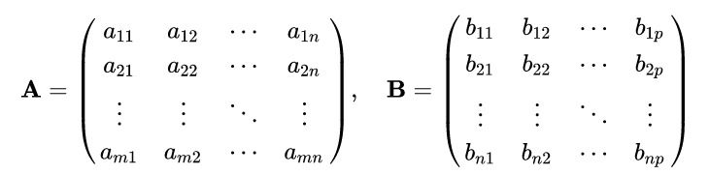
The matrix product C = AB is defined to be the m × p matrix
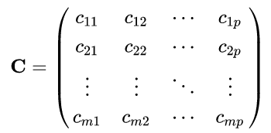
such that
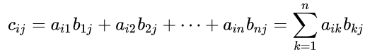
for i = 1, ..., m and j = 1, ..., p.

That is, the entry c_{ij} of the product is obtained by multiplying term-by-term the entries of the i-th row of A and the j-th column of B, and summing these n products. In other words, c_{ij} is the dot product of the i-th row of A and the j-th column of B.

Therefore, AB can also be written as
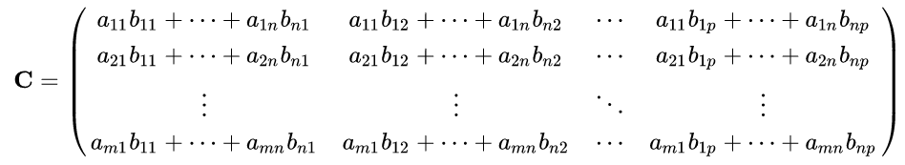

Thus the product AB is defined if and only if two matrices A and B are compatible: the number of columns in A equals the number of rows in B, in this case n.

To multiply matrix A of size m × n by the matrix B of size n × p we get a matrix C of size m × p. Number of operations for matrix multiplication is proportional to
m * n * p

E-OLYMP 1482. Matrix multiplication Find the product of two matrices.
► Multiply matrices using the formula:
$c_{i,j}=\sum_{k=1}^{n}{a_{i,k}b_{k,j}}$, where i = 1, 2, …, m; j = 1, 2, …, q.
Store the matrices A, B, C in two dimentional arrays a, b, c. Let A has the size na × ma, B has the size nb × mb. Matrices are compatible for multiplication if ma = nb. Resulting matrix C has the size na × mb.

for (i = 0; i < na; i++)
for (j = 0; j < mb; j++)
for (k = 0; k < ma; k++)
c[i][j] += a[i][k] * b[k][j];

Matrix chain multiplication problem
We are given a sequence (chain) <A₁, A₂, . . . , A_{n}> of n matrices to be multiplied, and we wish to compute the product A₁ * A₂ * . . . * A_{n}.
We can evaluate the expression using the standard algorithm for multiplying pairs of matrices as a subroutine once we have parenthesized it to resolve all ambiguities in how the matrices are multiplied together. A product of matrices is fully parenthesized if it is either
- a single matrix;
- the product of two fully parenthesized matrix products, surrounded by parentheses;
Matrix multiplication is associative, and so all parenthesizations yield the same product. For example, if the chain of matrices is <A₁, A₂, A₃, A₄>, the product A₁A₂A₃A₄ can be fully parenthesized in five distinct ways:
( A₁ (A₂ (A₃ A₄ ) ) ) ,
( A₁ ( ( A₂ A₃) A₄ ) ) ,
( ( A₁ A₂) (A₃ A₄ ) ) ,
( ( A₁ (A₂ A₃ ) ) A₄) ,
( ( ( A₁ A₂ ) A₃ ) A₄) .

The way we parenthesize a chain of matrices can have a dramatic impact on the cost of evaluating the product. To illustrate the different costs incurred by different parenthesizations of a matrix product, consider the problem of a chain <A₁, A₂, A₃> of three matrices. Suppose that the dimensions of the matrices are
If we multiply according to the parenthesization ( ( A₁ A₂ ) A₃ ), we perform 7500 scalar multiplications.
If we multiply according to the parenthesization ( A₁ (A₂ A₃ ) ), we perform 75000 scalar multiplications.

Thus, computing the product according to the first parenthesization is 10 times faster.

The matrix-chain multiplication problem can be stated as follows: given a chain <A₁, A₂, . . . , A_{n}> of n matrices, where for i = 1, 2, . . . , n, matrix A_{i} has dimension p_{i−1} × p_{i}, fully parenthesize the product A₁ A₂ . . . A_{n} in a way that minimizes the number of scalar multiplications.

Note that in the matrix-chain multiplication problem, we are not actually multiplying matrices. Our goal is only to determine an order for multiplying matrices that has the lowest cost.

Counting the number of parenthesizations
First let us convince ourselves that exhaustively checking all possible parenthesizations does not yield an efficient algorithm. Denote the number of alternative parenthesizations of a sequence of n matrices by P(n).
If n = 1, there is just one matrix and therefore only one way to fully parenthesize the matrix product. P(1) = 1
If n ≥ 2, a fully parenthesized matrix product is the product of two fully parenthesized matrix subproducts, and the split between the two subproducts may occur between the k-th and (k + 1)-st matrices for any k = 1, 2, . . . , n − 1.
Thus, we obtain the recurrence
P(n) = $\begin{aligned}\left\{1,n=1 | \right.\end{aligned}$
For example,
P(1) = 1
P(2) = P(1) * P(1) = 1;
P(3) = P(1) * P(2) + P(2) * P(1) = 1 + 1 = 2;
P(4) = P(1) * P(3) + P(2) * P(2) + P(3) * P(1) = 2 + 1 + 2 = 5;
P(5) = P(1) * P(4) + P(2) * P(3) + P(3) * P(2) + P(4) * P(1) = 5 + 2 + 2 + 5 = 14

The solution to a similar recurrence is the sequence of Catalan numbers, which grows as Ω(4^{n} / n^{3/2}). The number of solutions is thus exponential in n, and the brute-force method of exhaustive search is therefore a poor strategy for determining the optimal parenthesization of a matrix chain.

Catalan numbers are given by recurrence relation:
с₀ = 1,
с_{n} = c₀c_{n-1} + c₁c_{n-2} + c₂c_{n-3} + ... + c_{n-1}c₀ = $\sum_{k=0}^{n−1}{c_{k}c_{n−k−1}}$, if n > 0
We have: с₀ = 1, с₁ = 1, с₂ = 2, с₃ = 5, с₄ = 14, … . So P(i) = c_{i-1}.

E-OLYMP 9643. Catalan numbers Compute the n-th Catalan numbers modulo m.
► Let’s compute first Catalan numbers:
- с₀ = 1
- с₁ = c₀c₀ = 1,
- с₂ = c₀c₁ + c₁c₀ = 1 + 1 = 2,
- с₃ = c₀c₂ + c₁c₁ + c₂c₀ = 2 + 1 + 2 = 5,
- с₄ = c₀c₃ + c₁c₂ + c₂c₁ + c₃c₀ = 5 + 2 + 2 + 5 = 14,
- с₅ = c₀c₄ + c₁c₃ + c₂c₂ + c₃c₁ + c₄c₀ = 14 + 5 + 4 + 5 + 14 = 42
Since the value of с_{n} is recalculated through all the previous values of c₀, c₁, c₂, ..., c_{n-1}, then the values of the Catalan numbers we shall store in linear array
long long cat[10001]
Calculate the Catalan numbers using the recurrent formula.

cat[0] = 1;
for (i = 1; i <= n; i++)
{
for (j = 0; j < i; j++)
cat[i] = cat[i] + cat[j] * cat[i - j - 1];
}

Do not forget in this problem to make calculations modulo m.

Recurrent formula
Let A_{ij} be the product of matrices A_{i}A_{i+1}…A_{j}.
Let f(i, j) be the minimum cost of computing the value of A_{ij}.
It's obvious that:
- f(i, i) = 0 because A_{ii} = A_{i} (chain consists of just one matrix);
- f(i, i + 1) = p_{i−1} * p_{i} * p_{i+1} because we multiply matrices of sizes p_{i−1} × p_{i} and p_{i} × p_{i+1}.
Let us assume that the optimal parenthesization splits the product A_{i}A_{i+1}…A_{j} between A_{k} and A_{k+1}, where i ≤ k < j. Note that
- for k = i we have the product A_{i} * A_{i+1}…A_{j};
- for k = j – 1 we have the product A_{i}A_{i+1}… A_{j–1} * A_{j};
The value of f(i, j) is equal to the minimum cost for computing the subproducts A_{i,k} and A_{k+1,j} plus the cost of multiplying these two matrices together (which is p_{i−1} * p_{k} * p_{j}). Thus, we obtain
f(i, j) = f(i, k) + f(k + 1, j) + p_{i−1} * p_{k} * p_{j}

This recursive equation assumes that we know the value of k, which we do not. There are only j − i possible values for k, however, namely k = i, i +1, . . . , j −1. Since the optimal parenthesization must use one of these values for k, we need only check them all to find the best. Thus, our recursive definition for the minimum cost of parenthesizing the product A_{i}A_{i+1}…A_{j} becomes
$$f(i,j)=\begin{aligned}\left\{0,\text{if}i=j | \right.\end{aligned}$$

Example
Consider the next four matrices that we want to multiply:
The size of matrix A_{i} is p_{i−1} × p_{i}, array p contains the values (2, 4, 5, 3, 6), indexation starts from 0, i.e. p₀ = 2.
Let the values of f(i, j) will be saved in dp[i][j]. Initially set
dp[i][j] = ∞ (i ≠ j), dp[i][i] = 0

Next compute the values dp[i][i + 1] = p_{i−1} * p_{i} * p_{i+1}:
- dp[1][2] = p₀ * p₁ * p₂ = 2 * 4 * 5 = 40;
- dp[2][3] = p₁ * p₂ * p₃ = 4 * 5 * 3 = 60;
- dp[3][4] = p₂ * p₃ * p₄ = 5 * 3 * 6 = 90;

Continue the computations:

And here is how to find the final value dp[1][4]:

E-OLYMP 9647. Optimal Matrix Multiplication Chain of matrices is given. Print the minimum number of multiplications sufficient to multiply all matrices.
► Declare the constants INF = ∞, MAX = 11 (maximum possible number of matrices in the product). Declare arrays dp and p.

#define INF 0x3F3F3F3F3F3F3F3FLL
#define MAX 11
long long dp[MAX][MAX], p[MAX];

Function Mult finds the minimum number of multiplications sufficient to compute A_{ij} = A_{i} * A_{i+1} * … * A_{j-1} * A_{j}, which is saved in the cell dp[i][ j].

long long Mult(int i, int j)
{
if (dp[i][j] == INF)
for (int k = i; k < j; k++)
{
long long temp = Mult(i, k) + Mult(k + 1, j) +
p[i - 1] * p[k] * p[j];
if (temp < dp[i][j]) dp[i][j] = temp;
}
return dp[i][j];
}

In the main part of the program after reading the data, make a call
Mult(1,n);
to compute the result, the minimum number of multiplications to find the optimal product of matrices A₁ * A₂ * … * A_{n-1} * A_{n}.

E-OLYMP 1521. Optimal Matrix Multiplication - 2 Chain of matrices is given. Find the way to multiply them minimizing the number of scalar multiplications.
► Use the recurrent formula given above.

