Polymorphism in Java

The word polymorphism means having many forms. In simple words, we can define polymorphism as the ability of a message to be displayed in more than one form.

Real life example of polymorphism: a person at the same time can have different characteristic. Like a man at the same time is a father, a husband, an employee. So the same person posses different behaviour in different situations. This is called polymorphism.

Polymorphism is considered as one of the important features of Object Oriented Programming. Polymorphism allows us to perform a single action in different ways. In other words, polymorphism allows you to define one interface and have multiple implementations. The word “poly” means many and “morphs” means forms, So it means many forms.

In Java polymorphism is mainly divided into two types:
- Compile time Polymorphism
- Runtime Polymorphism

1. Compile time polymorphism: It is also known as static polymorphism. This type of polymorphism is achieved by function overloading or operator overloading.
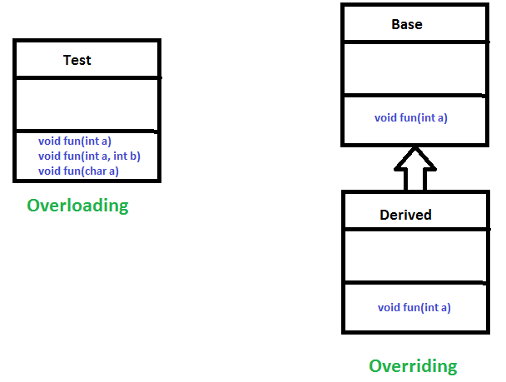

Method Overloading: When there are multiple functions with same name but different parameters then these functions are said to be overloaded. Functions can be overloaded by change in number of arguments or/and change in type of arguments.

By using different number of arguments

class MyInteger {
// Method with 2 parameter
static int Multiply(int a, int b)
{
return a * b;
}

// Method with the same name but 3 parameter
static int Multiply(int a, int b, int c)
{
return a * b * c;
}
}

class Main {
public static void main(String[] args)
{
System.out.println(MyInteger.Multiply(2, 4));
System.out.println(MyInteger.Multiply(2, 7, 3));
}
}

By using different types of arguments

class MyInteger {
// Method with 2 parameter
static int Multiply(int a, int b)
{
return a * b;
}

// Method with the same name but different types
static double Multiply(double a, double b)
{
return a * b;
}
}

class Main {
public static void main(String[] args)
{
System.out.println(MyInteger.Multiply(2, 4));
System.out.println(MyInteger.Multiply(2.6, 7.3));
}
}

2. Runtime polymorphism: It is also known as Dynamic Method Dispatch. It is a process in which a function call to the overridden method is resolved at Runtime. This type of polymorphism is achieved by Method Overriding.
Method overriding, on the other hand, occurs when a derived class has a definition for one of the member functions of the base class. That base function is said to be overridden.

import java.util.*;

class Parent {
void Print()
{
System.out.println("parent class");
}
}

class subclass1 extends Parent {
void Print()
{
System.out.println("subclass1");
}
}

class subclass2 extends Parent {
void Print()
{
System.out.println("subclass2");
}
}

class subclass3 extends Parent {

}

class Main {
public static void main(String[] args)
{
Parent a;
a = new subclass1();
a.Print();

a = new subclass2();
a.Print();

a = new subclass3();
a.Print();
}
}

Shape example.

class Shape{
void draw(){System.out.println("drawing...");}
}

class Rectangle extends Shape{
void draw(){System.out.println("drawing rectangle...");}
}

class Circle extends Shape{
void draw(){System.out.println("drawing circle...");}
}

class Triangle extends Shape{
void draw(){System.out.println("drawing triangle...");}
}

class Main{
public static void main(String args[]){
Shape s;
s = new Rectangle();
s.draw();

s = new Circle();
s.draw();

s = new Triangle();
s.draw();
}
}

Animal example.

class Animal{
void eat(){System.out.println("eating...");}
}

class Dog extends Animal{
void eat(){System.out.println("eating bread...");}
}

class Cat extends Animal{
void eat(){System.out.println("eating rat...");}
}

class Lion extends Animal{
void eat(){System.out.println("eating meat...");}
}

class Main{
public static void main(String[] args){
Animal a;
a = new Dog();
a.eat();

a = new Cat();
a.eat();

a = new Lion();
a.eat();
}
}

Polymorphism with Multilevel Inheritance

class Animal{
void eat(){System.out.println("eating");}
}

class Dog extends Animal{
void eat(){System.out.println("eating fruits");}
}

class BabyDog extends Dog{
void eat(){System.out.println("drinking milk");}
}

class Main{
public static void main(String args[]){
Animal a1 = new Animal();
a1.eat();

Animal a2 = new Dog();
a2.eat();

Animal a3 = new BabyDog();
a3.eat();
}
}

E-OLYMP 9425. Fractions: addition and subtraction Find the sum and difference of two fractions.
► Implement MyLong class:

class MyLong
{
private long a;
MyLong(long a);
MyLong(Long a);
MyLong Abs();
long GetValue();
private static long gcd(long a, long b);
static MyLong gcd(MyLong a, MyLong b);
MyLong Add(MyLong a);
MyLong Sub(MyLong a);
MyLong Mult(MyLong a);
MyLong Divide(MyLong a);
public String toString();
}

Implement Fraction class:

class Fraction
{
MyLong numerator, denominator;
Fraction ();
Fraction (MyLong numerator, MyLong denominator);
Fraction(String s);
Fraction Add(Fraction a);
Fraction Sub(Fraction a);
public String toString();
}

