Exceptions

The following code

public class Main
{
public static void main(String[] args)
{
int i = 5 / 0;
System.out.println("Some other operation");
}
}

will compile but during the runtime will print the next:
Exception in thread "main" java.lang.ArithmeticException: / by zero
at Main.main(Main.java:5)

Exception is a state that is not implicitly considered in the code. When exception happens, we say that program throws an exception.
Exceptions are events that occur during the execution of programs that disrupt the normal flow of instructions.

Consider the next example:

public class Main
{
public static void main(String[] args)
{
double i = 5.0 / 0;
System.out.println(i);
System.out.println("Some other operation");
}
}

In case of double / float division, the output is Infinity, the basic reason behind that it implements the floating point arithmetic algorithm which specifies a special values like “Not a number” OR “Infinity” for “divided by zero cases” as per IEEE 754 standards.
In case of integer division, it throws ArithmeticException.

There are different types of exceptions. Some of them:
When a mathematical operation related error happens, it throws
ArithmeticException

When program tries to access an array element with the index that greater than the (array size – 1) it throws
ArrayIndexOutOfBoundsException

public class Main
{
public static void main(String[] args)
{
int m[] = {1,2,3,4,5};
System.out.println(m[5]);
}
}

Exception in thread "main" java.lang.ArrayIndexOutOfBoundsException: 5
at Main.main(Main.java:6)

A special null value can be assigned to an object reference.
NullPointerException
is thrown when program attempts to use an object reference that has the null value.

import java.util.*;

class Point
{
int x, y;
}

public class Main
{
public static void main(String[] args)
{
Point p = null;
System.out.println(p.x + " " + p.y);
}
}

Exception in thread "main" java.lang.NullPointerException
at Main.main(Main.java:13)

When a function call is invoked by a Java application, a stack frame is allocated on the call stack. The stack frame contains the parameters of the invoked method, its local parameters, and the return address of the method. The return address denotes the execution point from which, the program execution shall continue after the invoked method returns.

import java.util.*;

class Car {}

public class Main {
static void c() {
float z = 1.2345f;
System.out.println(z);
}

static void b(){
Car y = new Car();
c();
}

static void a(){
int x = 0;
b();
}

public static void main(String[] args){
a();
}
}

If there is no space for a new stack frame then, the
StackOverflowError
is thrown by the Java Virtual Machine (JVM).

import java.util.*;

public class Main
{
static int f(int n)
{
return f(n-1);
}

public static void main(String[] args)
{
f(5);
}
}

try-catch
Unplanned program terminations can be prevented by considering the exception case. try-catch block helps defining the main code in try {} block and put the reaction to the Exception in the catch() {} block.

public class Main
{
public static void main(String[] args)
{
try
{
int i = 5 / 0;
}
catch (ArithmeticException ae)
{
System.out.println("Error happened. Reason: " + ae.toString());
}
System.out.println("Some other operation");
}
}

E-OLYMP 9722. Java ArithmeticException For two integers a and b find the value of a / b. Catch an exception Division-by-Zero if b = 0.
► Use try-catch to catch an exception.

import java.util.*;

public class Main
{
public static void main(String[] args)
{
Scanner con = new Scanner(System.in);
while(con.hasNextInt())
{
int a = con.nextInt();
int b = con.nextInt();
int res = Integer.MAX_VALUE;
try
{
res = a / b;
}
catch (ArithmeticException ae)
{
System.out.println("Division by zero");
}
if (res != Integer.MAX_VALUE)
System.out.println(res);
}
con.close();
}
}

try-catch-finally
The general syntax of try/catch is shown below. Note that, a single try can have several catch blocks – each for different exception types: The finally block that is not mandatory, is executed in any case.

try {
// the operation is here
}
catch (ExceptionType1 ex1) {
// What to do if ExceptionType1 happened?
}
catch (ExceptionType2 ex2) {
// What to do if ExceptionType2 happened?
}
finally {
// This part will execute in any case, in the end.
}

Example.

public class Main
{
public static void main(String[] args)
{
int arr[] = { 0, 2, 3, 4, 5};
int a = arr[1]; int b = arr[0];

try
{
//a = arr[11];
System.out.println("Result :" + a / b);
}
catch (ArithmeticException ex1)
{
System.out.println("Arithmetic exception: " + ex1.toString());
}
catch (ArrayIndexOutOfBoundsException ex2)
{
System.out.println("Array index: " + ex2.toString());
}
finally
{
System.out.println("Array is processed");
}
}
}

Since all exceptions extend the Exception class, all possible exception catching can be replaced with one catch of the Exception.

public class Main
{
public static void main(String[] args)
{
int arr[] = { 0, 2, 3, 4, 5};
int a = arr[1]; int b = arr[0];

try
{
//a = arr[11];
System.out.println("Result :" + a / b);
}
catch (Exception ex)
{
System.out.println("An exception: " + ex.toString());
}
finally
{
System.out.println("Array is processed");
}
}
}

The throw keyword
The throw statement allows you to create a custom error. The throw statement is used together with an exception type. There are many exception types available in Java: ArithmeticException, FileNotFoundException, ArrayIndexOutOfBoundsException, etc.

ArithmeticException()
Constructs an ArithmeticException with no detail message.
ArithmeticException(String s)
Constructs an ArithmeticException with the specified detail message.

Throw an exception if age is below 18 (print "Access denied"). If age is 18 or older, print "Access granted":

public class Main
{
public static void main(String[] args)
{
int age = 10;
if (age < 18) {
throw new ArithmeticException("Access denied - You must be at least 18 years old.");
}
else {
System.out.println("Access granted - You are old enough!");
}
}
}

Working with data files
FileInputStream and FileOutputStream classes are used to work with data files (raw bytes). For example, it is convenient to read with FileInputStream image data.
To read from to write to a file, the corresponding object shall be created with the file name:
FileInputStream fis = new FileInputStream("file.in");
or
FileOutputStream fos = new FileOutputStream("file.out");
It is possible to pass an additional boolean append parameter to FileOutputStream constructor that will instruct to write data to the end of the file:
FileOutputStream fos = new FileOutputStream("file.out",true);

InputStream / OutputStream methods
read() method reads a single byte from the input stream and returns it as an integer value. When end of file is reached, it returns -1.
write(byte b) method writes a byte to the output stream.

E-OLYMP 9721. Java FileInputStream Input is a data file. Find the sum of bytes and print the answer.
► Use FileInputStream and FileOutputStream to read / write the data. Use try-catch-finally.
Use files in E-olymp system:
- input.txt for input data;
- output.txt for output data;
Check the box “Solution uses files for reading and writing”.

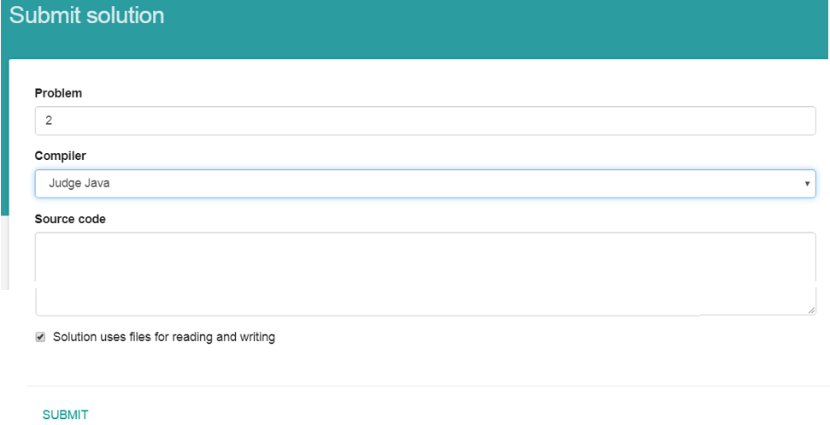
FileOutputStream writes to file bytes only. So if the answer for example is 123, you need to output three bytes with ASCII codes 49 (for symbol ‘1’), 50 (for symbol ‘2’), 51 (for symbol ‘3’).

import java.io.*;

public class Main
{
public static void main(String[] args) throws IOException
{
FileInputStream fis = null;
FileOutputStream fos = null;
try
{
int ch, sum = 0;
fis = new FileInputStream("input.txt");
fos = new FileOutputStream("output.txt");
while((ch = fis.read()) != -1)
{
sum += ch;
//System.out.println(ch);
}
//System.out.print(sum);
byte b[] = new byte[10]; // convert sum to sequence of bytes
int ptr = 0;
while(sum > 0)
{
b[ptr++] = (byte)(sum % 10);
sum /= 10;
}
while(--ptr >= 0)
//System.out.print(b[ptr]);
fos.write(b[ptr] + '0');
}

catch (Exception ex1) {
// If there is an error with file, this block will be executed
System.out.println("File error: " + ex1);
}

finally {
try {
fis.close();
fos.close();
}
catch (Exception ex2) {
System.out.println("Problem with closing: " + ex2);
}
}
}
}

read(byte [] b) method reads up to b.length bytes of data from this input stream into an array of bytes.
write(byte [] b) writes b.length bytes from the specified byte array to this output stream.

import java.io.*;

public class Main
{
public static void main(String[] args) throws IOException
{
FileInputStream fis = new FileInputStream("file.in");
FileOutputStream fos = new FileOutputStream("file.out");
byte d[] = new byte[100];
fis.read(d);
fos.write(d);
fis.close(); fos.close();
}
}

When operation with file is finished, the close() method shall be called. Closing a file releases any system resources associated with the stream. It also ensures that any output remaining in the output buffer is actually written to a file.

The Java FileReader class, java.io.FileReader makes it possible to read the contents of a file as a stream of characters. It works much like the FileInputStream except the FileInputStream reads bytes, whereas the FileReader reads characters. In other words the FileReader is intended to read text. One character may correspond to one or more bytes depending on the character encoding scheme.
The PrintWriter class, Java.io.PrintWriter prints formatted representations of objects to a text-output stream.

E-OLYMP 8811. Product of two integers Find the product of two integers.
► Read from input.txt and write to output.txt. Use try-catch-finally for opening / closing files. During the submition use files for reading and writing.

import java.util.*;
import java.io.*;

public class Main
{
public static void main(String[] args) throws IOException
{
Scanner con = null;
PrintWriter out = null;
try
{
con = new Scanner(new FileReader("input.txt"));
out = new PrintWriter(new File("output.txt"));

long a = con.nextLong();
long b = con.nextLong();
long res = a * b;
out.print(res);
}
catch (Exception ex) {
System.out.println("File error happened: " + ex);
}
finally
{
try
{
out.flush();
out.close();
con.close();
}
catch (Exception ex2) {
System.out.println("Cannot close an output file");
}
}
}
}

flush() writes the content of the buffer to the destination and makes the buffer empty for further data to store, but it does not closes the stream permanently. That means you can still write some more data to the stream.
close() closes the stream permanently. If you want to write some data further, then you have to reopen the stream again and append the data with the existing ones.

E-OLYMP 519. Sum of squares Find the sum of squares of two integers.
►Use files. Use try-catch-finally.

E-OLYMP 520. The sum of all Find the sum of all given integers.
►Use files. Use try-catch-finally.

A File object is created by passing in a String that represents the name of a file, or a String or another File object:
File file = new File("myExample.txt");

import java.util.*;
import java.io.*;

public class Main
{
public static void main(String[] args) throws IOException
{
PrintWriter out = null;
try
{
File file = new File("myExample.txt");
if (!file.exists()) file.createNewFile();

System.out.println(file.getName()); // returns the file name
// returns the absolute path
System.out.println(file.getAbsolutePath());
System.out.println(file.isFile()); // true, it is a file
System.out.println(file.length()); // length of the file

out = new PrintWriter(file);
out.println("My first message");
}
catch (Exception ex) {
System.out.println("File error happened: " + ex);
}
finally
{
try
{
out.flush();
out.close();
}
catch (Exception ex2) {
System.out.println("Cannot close an output file");
}
}
}
}

FileWriter class is used for writing streams of characters. Here is an example how to append data to the file.

import java.util.*;
import java.io.*;

public class Main
{
public static void main(String[] args) throws IOException
{
BufferedWriter bw = null;
try
{
File file = new File("myExample.txt");
if (!file.exists()) file.createNewFile();

// true = append to file
FileWriter fw = new FileWriter(file,true);
//BufferedWriter writer give better performance
bw = new BufferedWriter(fw);
bw.write("Message added");
}
catch (Exception ex) {
System.out.println("File error happened: " + ex);
}
finally
{
try
{
bw.flush();
bw.close();
}
catch (Exception ex2) {
System.out.println("Cannot close an output file");
}
}
}
}

