JAVA

Java Downloads for All Operating Systems
https://www.java.com/en/download/manual.jsp

Java Virtual Machine
The Java Virtual Machine (JVM) is a program whose purpose is to execute other programs. JVM manages system memory and provides a portable execution environment for Java-based applications.

The JVM has two primary functions: to allow Java programs to run on any device or operating system (known as the "Write once, run anywhere" principle), and to manage and optimize program memory. When Java was released in 1995, all computer programs were written to a specific operating system, and program memory was managed by the software developer. So the JVM was a revelation.
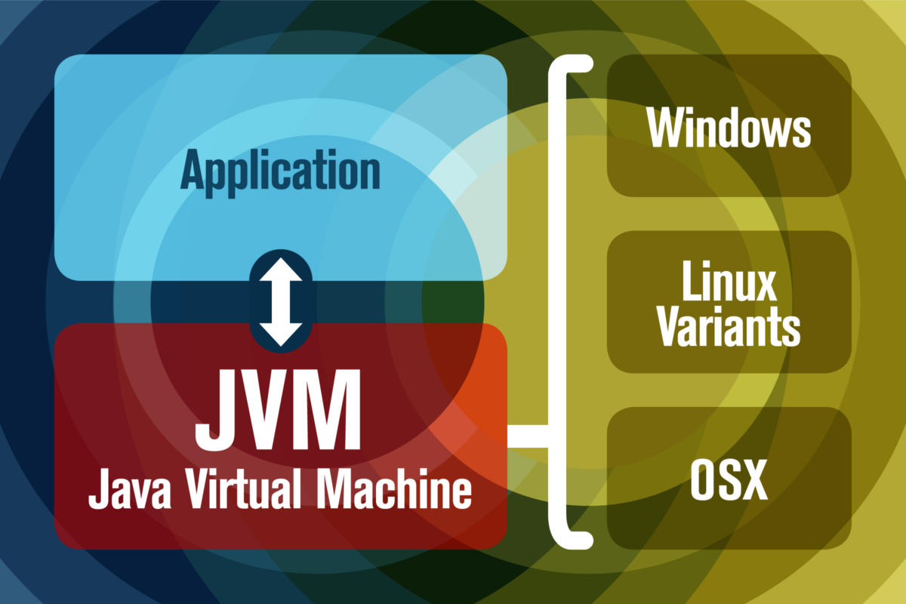

The JVM performs following operation:
- Loads code
- Verifies code
- Executes code
- Provides runtime environment

JVM is responsible for executing the java program line by line hence it is also known as interpreter.

Garbage collection
Before Java, all program memory was managed by the programmer. In Java, program memory is managed by the JVM. The JVM manages memory through a process called garbage collection, which continuously identifies and eliminates unused memory in Java programs. Garbage collection happens inside a running JVM.

Java Runtime Environment
Java Runtime Environment (JRE or Java RTE) provides the minimum requirements for executing a Java application; it consists of the Java Virtual Machine (JVM), core classes, and supporting files.
JRE is an installation package which provides environment to only run (not develop) the java program (or application) onto your machine. JRE is only used by those who only wants to run the Java Programs i.e. the users of your system.

Java Development Kit
The Standard Edition Java Development Kit (JDK) is a software development environment used for developing Java applications and applets. It includes the Java Runtime Environment (JRE), an interpreter/loader (Java), a compiler (javac), an archiver (jar), a documentation generator (Javadoc) and other tools needed in Java development.
https://www.oracle.com/technetwork/java/javase/downloads/jdk12-downloads-5295953.html

