DATA STRUCTURES

Preliminaries
What is a data structure?
- An organization of a data set
- Several operations to be performed on the data set
The general problem of data structure design
- Input: a data set and specifications of the operations to be supported
- Design: Come up with an organization (structure) of the data elements, and algorithms for the operations, so that the operations are as fast as possible.
When do we need a data structure?

Stack
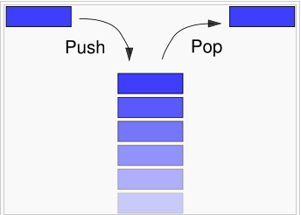
A stack is a basic data structure that can be logically thought of as a linear structure represented by a real physical stack or pile, a structure where insertion and deletion of items takes place at one end called top of the stack. The basic concept can be illustrated by thinking of your data set as a stack of plates or books where you can only take the top item off the stack in order to remove things from it. This structure is used all throughout programming.

The basic implementation of a stack is also called a LIFO (Last In First Out) to demonstrate the way it accesses data, since as we will see there are various variations of stack implementations.
There are basically three operations that can be performed on stacks. They are:
- inserting an item into a stack (push);
- deleting an item from the stack (pop);
- displaying the contents of the stack (peek or top);

#include <cstdio>
#include <stack>
using namespace std;

int main(void)
{
stack<int> s; // Create an empty stack

// push into stack the squares of numbers from 1 to 100
for (int i = 1; i <= 10; i++) s.push(i*i);

// create another stack using copy constructor
stack<int> t(s);

// print top of the stack and its size
printf("Top element is %d\n", t.top());
printf("Stack size is %d\n", t.size());

// print stack elements removing them from the top
while (!t.empty())
{
printf("%d ", t.top());
t.pop();
}
printf("\n");
return 0;
}

Java example

import java.util.*;

public class Main
{
public static void main(String[] args)
{
Scanner con = new Scanner(System.in);
Stack<Integer> s = new Stack<Integer>();
for (int i = 1; i <= 10; i++) s.push(i*i);

Stack<Integer> t = (Stack)s.clone();
System.out.println("Top element = " + t.peek());
System.out.println("Stack size = " + t.size());
while (!t.empty())
System.out.print(t.pop() + " ");
System.out.println();
con.close();
}
}

E-OLYMP 5087. Implement a stack Implement a stack with two operations: push and pop.
► Simulate stack operations.

