NP – Completeness

Almost all the algorithms we have studied have been polynomial time algorithms: on inputs of size n, their worst case running time is O(n^{k}) for some constant k. It is natural to wonder whether all problems can be solved in polynomial time. The answer is no. For example, there are problems that cannot be solved by any computer, no matter how much time is provided. There are also problems that can be solved, but not in time O(n^{k}) for any constant k.

The class P (polynomial) consists of those problems that are solvable in polynomial time. More specifically, they are problems that can be solved in time O(n^{k}) for some constant k, where n is the size of the input to the problem.

The class NP (not polynomial) consists of those problems that are “verifiable” in polynomial time. What we mean here is that if we were somehow given a “certificate” of a solution, then we could verify that the certificate is correct in time polynomial in the size of the input to the problem. For example, in the hamiltonian cycle problem, given a directed graph G = (V, E), a certificate would be a sequence (v₁, v₂, v₃, . . . ,v_{|V|}) of |V| vertices. It is easy to check in polynomial time that (v_{i}, v_{i+1}) ∈ E for i = 1, 2, 3, . . . , |V| − 1 and that (v_{|V|}, v₁) ∈ E as well.

The satus of “NP-complete” problems is unknown. No polynomial time algorithm has yet been discovered for an NP-complete problem, nor has anyone yet been able to prove that no polynomial time algorithm can exist for any one of them. This so-called P ≠ NP question has been one of the deepest open research problems in theoretical computer science since it was first posed in 1971.

Any problem in P is also in NP, since if a problem is in P then we can solve it in polynomial time without even being given a certificate. Now we can believe that P ⊆ NP. The open question is whether or not P is a proper subset of NP.

SAT Problem
An instance of SAT is a boolean formula φ composed of
1. n boolean variables: x₁, x₂, . . . , x_{n};
2. m boolean connectives: any boolean function with one or two inputs and one output, such as ∧ (AND), ∨ (OR), ￢ (NOT),→ (implication), ↔ (if and only if);
3. parentheses.

It is easy to encode a boolean formula φ in a length that is polynomial in n + m. As in boolean combinational circuits, a truth assignment for a boolean formula φ is a set of values for the variables of φ, and a satisfying assignment is a truth assignment that causes it to evaluate to 1. A formula with a satisfying assignment is a satisfiable formula. The satisfiability problem asks whether a given boolean formula is satisfiable; in formal-language terms,
SAT = {φ : φ is a satisfiable boolean formula}

As an example, the formula
φ = ((x₁ → x₂) ∨ ￢((￢x₁ ↔ x₃) ∨ x₄)) ∧ ￢x₂
has the satisfying assignment x₁ = 0, x₂ = 0, x₃ = 1, x₄ = 1, since
φ = ((0 → 0) ∨ ￢((￢0 ↔ 1) ∨ 1)) ∧ ￢0
= (1 ∨ ￢(1 ∨ 1)) ∧ 1 = (1 ∨ 0) ∧ 1 = 1

and thus this formula φ belongs to SAT.

The naive algorithm to determine whether an arbitrary boolean formula is satisfiable does not run in polynomial time. There are 2^{n} possible assignments in a formula φ with n variables. If the length of φ is polynomial in n, then checking every assignment requires O(2^{n}) time, which is superpolynomial in the length of φ.

3-CNF-SAT Problem
Define 3-CNF satisfiability using the following terms. A literal in a boolean formula is an occurrence of a variable or its negation. A boolean formula is in conjunctive normal form, or CNF, if it is expressed as an AND of clauses, each of which is the OR of one or more literals. A boolean formula is in 3-conjunctive normal form, or 3-CNF, if each clause has exactly three distinct literals.
For example, the boolean formula
(x₁ ∨￢x₁ ∨￢x₂) ∧ (x₃ ∨ x₂ ∨ x₄) ∧ (￢x₁ ∨￢x₃ ∨￢x₄)
is in 3-CNF. The first of its three clauses is (x₁ ∨￢x₁ ∨￢x₂), which contains the three literals x₁, ￢x₁ and ￢x₂.

In 3-CNF-SAT, we are asked whether a given boolean formula φ in 3-CNF is satisfiable. Satisfiability of boolean formulas in 3-conjunctive normal form is NP-complete.

Independent set Problem
An independent set is a set of verices in a graph, no two of which are adjacent. That is, it is a set S of vertices such that for every two vertices in S there is no edge connecting them. Equivalently, each edge in the graph has at most one endpoint in S. The size of an independent set is the number of vertices it contains.
A maximum independent set is an independent set of largest possible size for a given graph. The nine blue vertices form a maximum independent set.
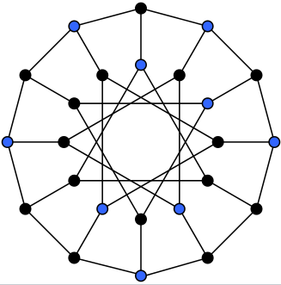

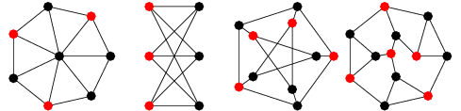

Clique Problem
A clique in an undirected graph G = (V, E) is a subset V’ ⊆ V of vertices, each pair of which is connected by an edge in E. In other words, a clique is a complete subgraph of G. The size of a clique is the number of vertices it contains. The clique problem is the optimization problem of finding a clique of maximum size in a graph. As a decision problem, we ask simply whether a clique of a given size k exists in the graph.

A maximum clique is a clique with the largest possible number of vertices.

Consider a social network, where the graph’s vertices represent people, and the graph’s edges represent mutual acquaintance. Then a clique represents a subset of people who all know each other, and algorithms for finding cliques can be used to discover these groups of mutual friends.

A naive algorithm for determining whether a graph G = (V, E) with |V| vertices has a clique of size k is to list all k-subsets of V, and check each one to see whether it forms a clique. The running time of this algorithm is O(k² * $C_{|V|}^{k}$), which is polynomial if k is a constant. In general, however, k could be near |V| / 2, in which case the algorithm runs in superpolynomial time.

The brute force algorithm finds a 4-clique in 7 vertex graph by systematically checking all 4-vertex subgraphs for completeness.
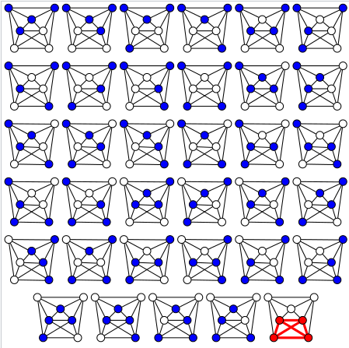

The maximum clique is {1, 2, 5}:
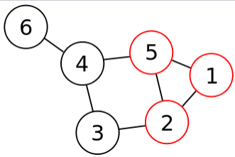

3-CNF – Clique reduction
Let φ = C₁ ∧ C₂ ∧ · · · ∧ C_{k} be a boolean formula in 3-CNF with k clauses. For r = 1, 2, . . . , k, each clause C_{r} has exactly three distinct literals l_{r1}, l_{r2} and l_{r3}. We shall construct a graph G such that φ is satisfiable if and only if G has a clique of size k.
The graph G = (V, E) is constructed as follows. For each clause Cr = (l_{r1} ∨ l_{r2} ∨ l_{r3}) in φ, we place a triple of vertices v_{r1}, v_{r2} and v_{r3} into V. We put an edge between two vertices v_{ri} and v_{sj}I if both of the following hold:
• v_{ri} and v_{sj} are in different triples, that is, r ≠ s, and
• their corresponding literals are consistent, that is, l_{ri} is not the negation of l_{sj}.

This graph can easily be computed from φ in polynomial time. As an example of this construction, if we have
φ = (x₁ ∨￢x₂ ∨￢x₃) ∧ (￢x₁ ∨ x₂ ∨ x₃) ∧ (x₁ ∨ x₂ ∨ x₃),
then G is the graph shown below:
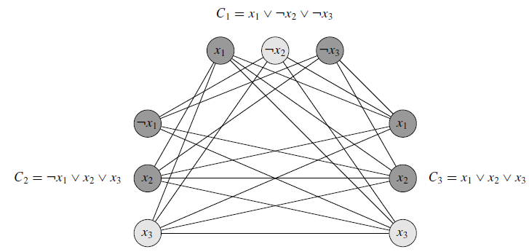
The graph G derived from the 3-CNF formula φ = C₁ ∧ C₂ ∧ C₃, where C₁ = (x₁ ∨ ￢x₂ ∨ ￢x₃), C₂ = (￢x₁ ∨ x₂ ∨ x₃) and C₃ = (x₁ ∨ x₂ ∨ x₃), in reducing 3-CNF-SAT to CLIQUE. A satisfying assignment of the formula has x₂ = 0, x₃ = 1, and x₁ may be either 0 or 1. This assignment satisfies C₁ with ￢x₂, and it satisfies C₂ and C₃ with x₃, corresponding to the clique with lightly shaded vertices.

We must show that this transformation of φ into G is a reduction. First, suppose that φ has a satisfying assignment. Then each clause C_{r} contains at least one literal l_{ri} that is assigned 1, and each such literal corresponds to a vertex v_{ri} . Picking one such “true” literal from each clause yields a set V’ of k vertices. We claim that V’ is a clique. For any two vertices v_{ri}, v_{sj} ∈ V’, where r ≠ s, both corresponding literals l_{ri} and l_{sj} are mapped to 1 by the given satisfying assignment, and thus the literals cannot be complements. Thus, by the construction of G, the edge (v_{ri} , v_{sj}) belongs to E.
Conversely, suppose that G has a clique V’ of size k. No edges in G connect vertices in the same triple, and so V’ contains exactly one vertex per triple. We can assign 1 to each literal l_{ri} such that v_{ri} ∈ V’ without fear of assigning 1 to both a literal and its complement, since G contains no edges between inconsistent literals. Each clause is satisfied, and so φ is satisfied. (Any variables that do not correspond to a vertex in the clique may be set arbitrarily.)
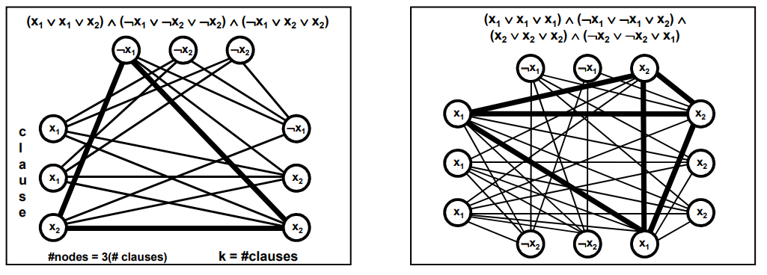

Vertex Cover Problem
A vertex cover of an undirected graph G = (V, E) is a subset V’ ⊆ V such that if (u, v) ∈ E, then u ∈ V’ or v ∈ V’ (or both). That is, each vertex “covers” its incident edges, and a vertex cover for G is a set of vertices that covers all the edges in E. The size of a vertex cover is the number of vertices in it.

The vertex cover problem is to find a vertex cover of minimum size in a given graph. Restating this optimization problem as a decision problem, we wish to determine whether a graph has a vertex cover of a given size k.

Theorem. The vertex-cover problem ∈ NP.
Proof. Suppose we are given a graph G = (V, E) and an integer k. The certificate we choose is the vertex cover V’ ⊆ V itself. The verification algorithm affirms that |V’| = k, and then it checks, for each edge (u, v) ∈ E, that u ∈ V’ or v ∈ V’. This verification can be performed straightforwardly in polynomial time.

Vertex Cover – Clique reduction
Given an undirected graph G = (V, E), we define the complement of G as G’ = (V, E’), where E’ = {(u, v) : u, v ∈ V, u ≠ v, and (u, v) ∉ E}. In other words, G’ is the graph containing exactly those edges that are not in G. Next figure shows a graph and its complement.
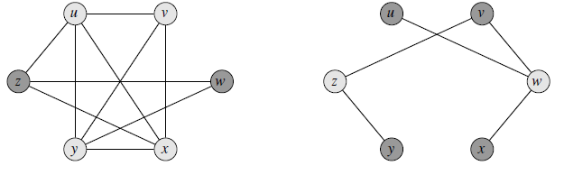
Left picture: an undirected graph G = (V, E) with clique V’ = {u, v, x, y}.
Right picture: the graph G produced by the reduction algorithm that has vertex cover V – V’ = {w, z}.

If there exist a clique V’ in G, then V – V’ is a vertex cover in G`

Suppose that G has a clique V’ ⊆ V with |V’| = k. We claim that V – V’ is a vertex cover in G. Let (u, v) be any edge in E’. Then, (u, v) ∉ E, which implies that at least one of u or v does not belong to V’, since every pair of vertices in V’ is connected by an edge of E. Equivalently, at least one of u or v is in V – V’, which means that edge (u, v) is covered by V – V’. Since (u, v) was chosen arbitrarily from E’, every edge of E’ is covered by a vertex in V – V’. Hence, the set V – V’, which has size |V| − k, forms a vertex cover for G.
Conversely, suppose that G has a vertex cover V_ ⊆ V, where |V’| = |V| − k. Then, for all u, v ∈ V, if (u, v) ∈ E’, then u ∈ V’ or v ∈ V’ or both. The contrapositive of this implication is that for all u, v ∈ V, if u ∉ V’ and v ∉ V’, then (u, v) ∈ E. In other words, V – V’ is a clique, and it has size |V| − |V’| = k.

