11081. Electronic lock

The traitors blocked the doors again. And to open them, you must enter the code.
The field for entering the code is an endless sequence of 7-segment indicators. It is known that the code is the largest positive integer, for displaying which no more than n burning segments are used.
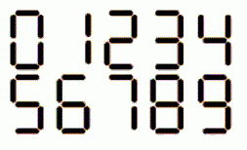
Help the team find out the code.

Input. The first line contains one integer n (2 ≤ n ≤ 10⁵) – the maximum number of burning segments when displaying the number.

Output. Print one number – the required code.

Sample input | Sample output
6 | 111

SOLUTION
constructive

Algorithm analysis
If n is even, then it is preferrable to use only ones to maximize the code. Print n / 2 ones.
If n is odd, print 7 as the first digit, and then print (n – 3) / 2 ones.

Example
For n = 8 the answer is 1111.
For n = 9 the answer is 7111.
For n = 10 the answer is 11111.

Algorithm realization
Read the input value of n.

scanf("%d", &n);

If n is odd, then print 7 as the first digit.

if (n % 2 == 1)
{
printf("7");

Decrease n by 3 because 3 burning segments are used for digit 7.

n -= 3;
}

Print n / 2 ones.

while (n > 0)
{
printf("1");
n -= 2;
}

printf("\n");

