11272. Anne’s game

A little girl named Anya likes to play the following game.
First, she draws one circle on a sheet of paper. Then she draws another circle and connects it to the first one with a line. After that, she draws a new circle and connects it with a line to one of the previously drawn circles. Anya continues in this way until she has drawn exactly n circles, and each new circle is connected to exactly one of the circles drawn earlier.
No circles ever intersect, and no lines intersect with each other. Finally, Anya numbers all the circles from 1 to n in an arbitrary order.
How many different pictures containing exactly circles can Anya draw? Two pictures are considered different if there exists a pair of numbers (i, j) such that in one picture the circles numbered i and j are connected by a line, while in the other picture they are not.

Input. The first line contains the number of test cases t. Each test case consists of a single line containing one integer n (0 < n ≤ 100).

Output. For each test case, print a line of the form “Case #x: res”, where x is the test case number and res is the remainder of the answer modulo 2000000011.

Sample input | Sample output
3  1  2  3 | Case #1: 1  Case #2: 1  Case #3: 3

SOLUTION
graphs – spanning tree

Algorithm analysis
The problem asks to determine the number of different labeled trees with n vertices. Equivalently, this is the number of spanning trees in the complete graph with n vertices.
Recall that a graph is called complete if every pair of its vertices is connected by an edge.

Theorem. There exists a one-to-one correspondence between the spanning trees of the complete graph with n vertices and Prüfer codes of length n – 2.

Lemma. The number of distinct Prüfer codes of length n – 2 is n^{n-2}.

Therefore, the number of different pictures that Anya can draw (that is, the number of labeled trees with n vertices) is equal to n^{n-2}.

Example
For n = 4, there are 16 different trees. Below each tree, the corresponding Prüfer code is shown.
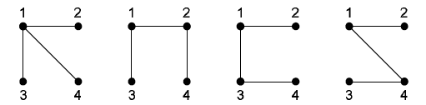
(1, 1) (1, 2) (1, 3) (1, 4)

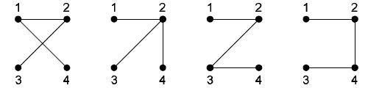
(2, 1) (2, 2) (2, 3) (2, 4)

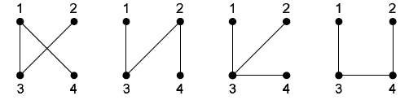
(3, 1) (3, 2) (3, 3) (3, 4)

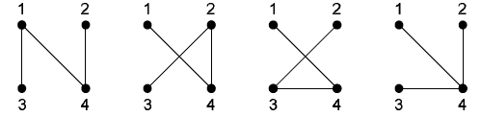
(4, 1) (4, 2) (4, 3) (4, 4)

Algorithm implementation
Read the number of test cases tests.

scanf("%d",&tests);
for (t = 1; t <= tests; t++)
{

For each test case, read the value n.

scanf("%d",&n);

Compute and print the value n^{n-2} modulo 2000000011.

res = 1;
for (i = 0; i < n - 2; i++)
res = (res * n) % 2000000011;
printf("Case #%d: %lld\n",t,res);
}

