11348. Dead-end detector

The council of your hometown has decided to improve road sign placement, especially for dead ends. They have given you a road map, and you must determine where to put up signs to mark the dead ends. They want you to use as few signs as possible.
The road map is a collection of locations connected by two-way streets. The following rule describes how to obtain a complete placement of dead-end signs. Consider a street S connecting a location x with another location. The x-entrance of S gets a dead-end sign if, after entering S from x, it is not possible to come back to x without making a U-turn. A U-turn is a 180-degree turn immediately reversing the direction.
To save costs, you have decided not to install redundant dead-end signs, as specified by the following rule. Consider a street S with a dead-end sign at its x-entrance and another street T with a dead-end sign at its y-entrance. If, after entering S from x, it is possible to go to y and enter T without making a U-turn, the dead-end sign at the y-entrance of T is redundant. See Figure E.1 for examples.
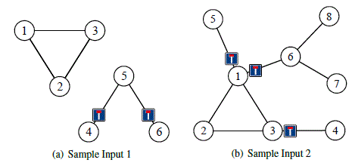
Figure E.1: Illustration of sample inputs, indicating where non-redundant dead-end signs are placed.

Input. The first line contains two integers n and m, where n (1 ≤ n ≤ 5 ⋅ 10⁵) is the number of locations and m (0 ≤ m ≤ 5 ⋅ 10⁵) is the number of streets. Each of the following m lines contains two integers v and w (1 ≤ v < w ≤ n) indicating that there is a two-way street connecting locations v and w. All location pairs in the input are distinct.

Output. On the first line, output k, the number of dead-end signs installed. On each of the next k lines, output two integers v and w marking that a dead-end sign should be installed at the v-entrance of a street connecting locations v and w. The lines describing dead-end signs must be sorted in ascending order of v-locations, breaking ties in ascending order of w-locations.

Sample input 1 | Sample output 1
6 5  1 2  1 3  2 3  4 5  5 6 | 2  4 5  6 5
Sample input 2 | Sample output 2
8 8  1 2  1 3  2 3  3 4  1 5  1 6  6 7  6 8 | 3  1 5  1 6  3 4

SOLUTION
biconnected components

Algorithm analysis
В левой

Example
The next graphs have two and three dead ends correspondingly:

Algorithm realization
Читаем количество.

