11531. Interesting places

One day Herman was walking around the city and, out of boredom, was marking the places he should visit. He wrote down the coordinates (x, y) of these points in his new, just-released device, “IKup”. When the exclusively non-alcoholic drinks lover had already returned to his home, he found that there were quite a lot of records, and it would be quite problematic to visit all the places of his interest. But Herman did not give up and began to think up an optimal algorithm to bypass these very places. It seems that he did not suspect that his love for exclusively non-alcoholic drinks will help him to solve the problem, which under normal circumstances he would not have solved...
Since the algorithm turned out to be quite complicated, Herman could not fully realize it himself and asks for your help. Namely, he needs to know if there exists a straight line that exactly divides his set of points into two different parts in such a way that it is possible to match each point from one part with some point from the other part, and that they are symmetrically located with respect to this line. Note that points that are located exactly on the straight line do not belong to either part and thus do not need to be matched.

Input. The first line contains one integer n (2 ≤ n ≤ 10⁵) – the number of points.
The next n lines each contain two integers x and y (-10⁴ ≤ x, y ≤ 10⁴) – the coordinates of the points.

Output. Output “YES” (without quotes) if there exists a line that divides points into two different parts in such a way that it is possible to map each point from one part to a point from the other part, that they are symmetrically located with respect to this line, or if the line passes through all points.
If such a line does not exist, print “NO” (without quotes).

Examples. Illustration of the first example:
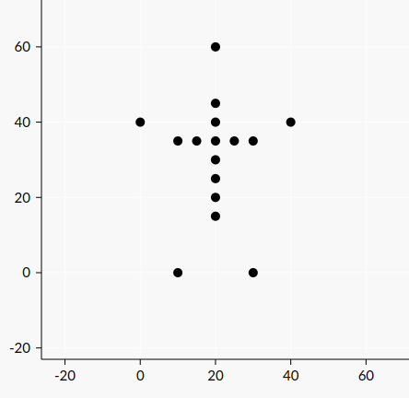

Illustration of the second example:
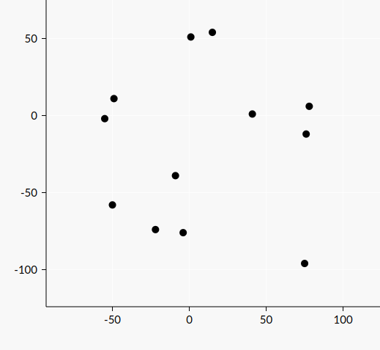
Sample input 1 | Sample output 1
16  10 0  30 0  0 40  20 60  40 40  20 40  20 45  20 35  20 30  20 25  20 20  20 15  15 35  10 35  25 35  30 35 | YES
Sample input 2 | Sample output 2
12  -49 11  75 -96  -55 -2  -4 -76  -9 -39  1 51  15 54  78 6  -22 -74  41 1  76 -12  -50 -58 | NO

SOLUTION
ххх

Анализ алгоритма
Если.

Пример
На.

Реализация алгоритма
Функция.

