1317. Birthdays

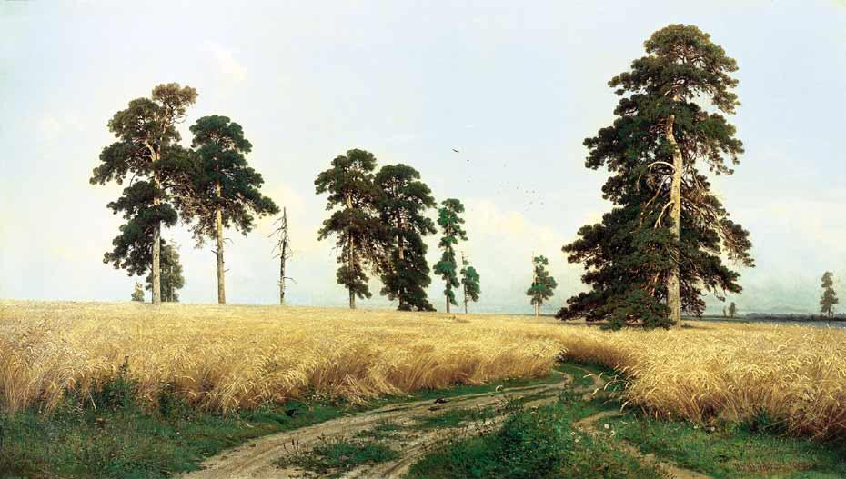
Рожь. 1878. Пейзаж стал классическим и программным произведением, как для самого художника, так и для художественной критики его времени. На одном из эскизов к картине И.И. Шишкин сделал запись, которую можно считать его творческим кредо: «Раздолье, простор, угодье, рожь, Божья благодать, русское богатство».
Лирическое отношение к отечественной природе, воспетое И.И. Шишкиным, было ярко выражено в стихах Н.А. Некрасова:

Все рожь кругом, как степь живая,
Ни замков, ни морей, ни гор.
Спасибо, сторона родная,
За твой врачующий простор.

It is known that in a group of 23 or more people, the probability that at least two of them share the same birthday (day and month) exceeds 50%. This fact may seem paradoxical, since the probability of a single person being born on a specific day of the year is very small, and the probability that two people share a birthday is even smaller. However, the result is confirmed by probability theory. Therefore, this fact is not a paradox in the strict scientific sense — there is no logical contradiction. The paradox lies only in the discrepancy between our intuition and the result of the mathematical calculation.
Given a number of people, calculate the probability that at least two of them share the same birthday. Assume that a year has 365 days.

Input. Each line represents a separate test and contains the number of people n (1 < n < 400).

Output. For each value of n, print on a separate line the probability (in percent) that at least two of the n people share the same birthday (day and month). Print the probability with 8 digits after the decimal point.

Sample input | Sample output
2  10  23  366 | 0.27397260%  11.69481777%  50.72972343%  100.00000000%

SOLUTION
probability

Algorithm analysis
First, let’s compute the probability $\overline{p(n)}$that in a group of n people all birthdays are distinct. If n is greater than 365, then by the pigeonhole principle this probability is zero. If n does not exceed 365, we reason as follows.
We choose the first person and note his birthday. Then we choose the second person: the probability that his birthday does not coinside with the first person’s birthday is 1 – 1 / 365. For the third person, the probability that his birthday does not coinside with the birthdays of the first two people is 1 – 2 / 365.
Continuing this reasoning, for the last person the probability that their birthday does not coinside with the birthdays of all the previous ones is 1 – (n – 1) / 365.
Multiplying all these probabilities, we obtain the probability that all birthdays in the group are different:
$$\overline{p(n)}=1⋅\left(1-\frac{1}{365}\right)⋅\left(1-\frac{2}{365}\right)⋅...⋅\left(1-\frac{n-1}{365}\right)$$
Then, the probability that at least two people out of n share the same birthday is equal to one minus the probability that all birthdays are distinct:
$$p(n)=1-\overline{p(n)}$$

Algorithm implementation
In the array p[i] we’ll store the corresponding probability values p(i).

double p[401];

Let p[1] = 1. The remaining values of the array p[i] are computed using the formula given in the problem analysis.

p[1] = 1.0;
for (i = 2; i < 401; i++)
p[i] = p[i-1] * (1.0 - (i - 1.0) / 365);

For each input value n, compute the corresponding probability and print the result.

while (scanf("%d",&n) == 1)
printf("%.8lf%%\n",(1 - p[n]) * 100);

