2667. Snake

Write a program that prints an integer located at line x and column y of matrix n × m that is filled like a snake:
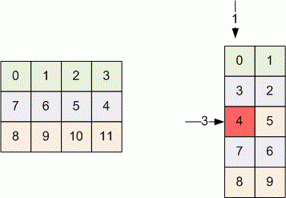

Input. Given the integers n, m, x, y (1 ≤ x ≤ n ≤ 50, 1 ≤ y ≤ m ≤ 50). Here n is number of matrix lines, m is number of matrix columns, x and y are the numbers of row and column of element to print.

Output. Print the element of line x and column y.

Sample Input
5 2 3 1

Sample Output
4

SOLUTION
two-dimentional array

Анализ алгоритма

Реализация алгоритма

