7466. Balanced Binary Tree

Given an array of integers. Create a Binary Search Tree from these numbers. If the inserted value equals to the current node, insert it to the right subtree.
Write a method IsBalanced that determine if it is height-balanced. A height-balanced binary tree is defined as a binary tree in which the depth of the two subtrees of every node never differ by more than 1.
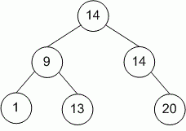
Write the code according to the next interface:

class TreeNode
{
public:
int val;
TreeNode *left;
TreeNode *right;
TreeNode(int x) : val(x), left(NULL), right(NULL) {}
};

class Tree
{
public:
TreeNode *head;
Tree() : head(NULL) {};
void Insert(int val); // Insert number val to Binary Search Tree
int IsBalanced(void); // Return 1 if the tree is height-balanced, and
// 0 otherwise
};

You can create (use) additional methods if needed.

Input. The first line contains number n (1 ≤ n ≤ 100). The second line contains n integers.

Output. Create the Binary Search Tree from input data. Print 1 if it is height-balanced and 0 otherwise.

Sample Input
6
14 9 1 14 20 13

Sample Output
1

SOLUTION
ООP – Trees

Algorithm analysis

Algorithm realization

