8373. Inverted Tower

The Babylonians decided to build an amazing tower – expanding to the top and containing an infinite number of floors and rooms. It is arranged as follows – on the first floor there is one room, then there are two floors each with two rooms, then there are three floors, each with three rooms and so on.
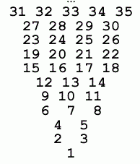
This tower was decided to equip with an elevator – and here is the problem: given room number you need to determine the floor and position of the room on that floor from the left.

Input. Room number n (1 ≤ n ≤ 2 * 10⁹).

Output. Print two space separated integers: the floor and the position of the room on that floor from the left.

Sample input 1 | Sample output 1
1 | 1 1
Sample input 2 | Sample output 2
5 | 3 2

SOLUTION
mathematics

Анализ алгоритма

Реализация алгоритма

