8375. One rectangle

In the square 0 ≤ x ≤ 100, 0 ≤ y ≤ 100 there are n points with integer coordinates. You should find out rectangle which has no any of given point inside and has maximum possible area.
Remark: Points are permitted to be on the border of the rectangle.
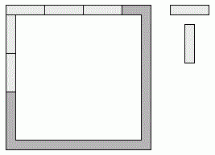

Input. First line has the number n (1 ≤ n ≤ 100), next n lines has coordinates of n points.

Output. Your program should output one number - maximum area.

Sample input 1 | Sample output 1
1  50 50 | 5000
Sample input 2 | Sample output 2
3  25 25  50 50  75 75 | 3750

SOLUTION
geometry

Анализ алгоритма

Реализация алгоритма

