Visual Studio Installation
www.visualstudio.com

1. Run antivirus on your computer to remove viruses. Viruses can block Visual Studio installation.
2. go to www.visualstudio.com
3. In the right upper corner you can find Free Visual Studio.
4. Choose and install Visual Studio Community version.
5. During installation default language is C#. Choose C++ before installation starts.

Solve Of CRT SECURE NO WARNINGS problem
https://www.youtube.com/watch?v=NZW7djD3mH8

Preventing console window from closing on Visual Studio Console application
http://stackoverflow.com/questions/1775865/preventing-console-window-from-closing-on-visual-studio-c-c-console-applicatio

Project Properties → Configuration Properties → Linker → System
select Console (/SUBSYSTEM:CONSOLE) in SubSystem option.

Creating a New Project using Visual Studio

The first time you open Visual Studio, it will appear like this:

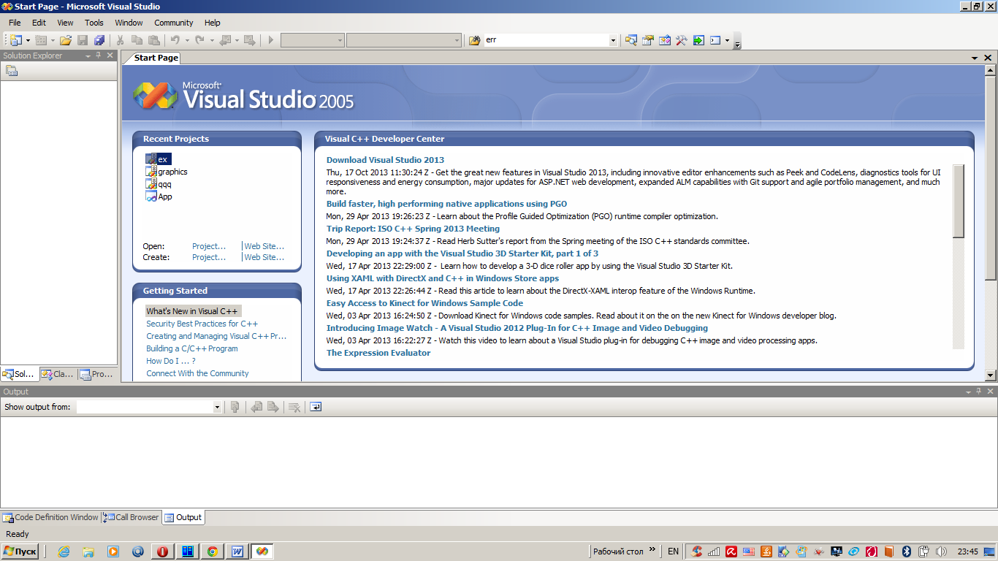

Visual Studio is simply an application, as are Microsoft Word and Internet Explorer, except Visual Studio is an application that you use to create other applications.

To create a new C++ project, with Visual Studio running, follow these steps (note that the names of menus, dialog boxes, and other options might be different if you have a different version of Visual Studio):
1. From the File menu, select New and then Project.
2. Select Win32 under Project Types.
3. Select Win32 Console Application under Templates.
4. Enter Hello World in the Name field. You will see that Solution Name also gets filled out as you type. Choose Location for your project.
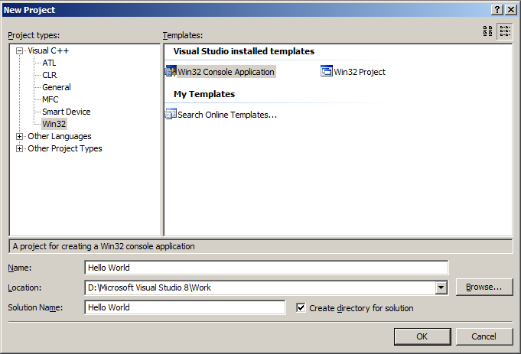

5. Click OK. The Win32 Application Wizard dialog window will appear. This is where you can further customize your project. Click Next.
6. Here you can select additional options for your project. The only option you’ll need right now is Empty Project, so check that. Click Finish.
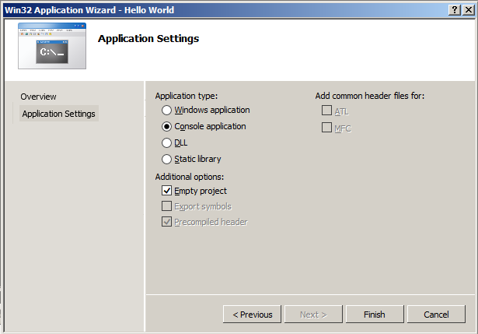
7. The project has now been created. There is a window on the left-hand side labeled Solution Explorer. This is where you can see all of the files in your project. Right now the project is empty, so let’s add a file. Right-click on the project name, Hello World, in the Solution Explorer.
8. In the menu that appears, select Add and then New Item.

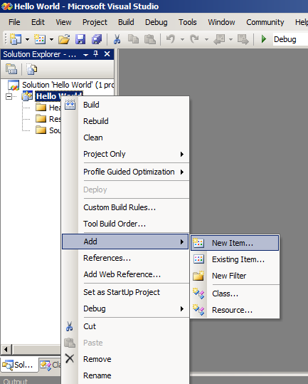

9. The Add New Item dialog window appears. Here, select C++ File (.cpp) under Templates and type Hello World in the Name field. Choose Code under Categories. Click Add.

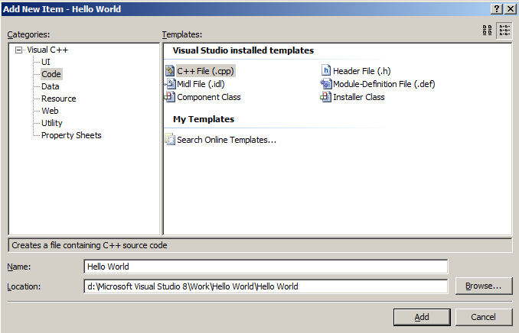

10. The file is now created and open for editing. Type in the “Hello World” program.

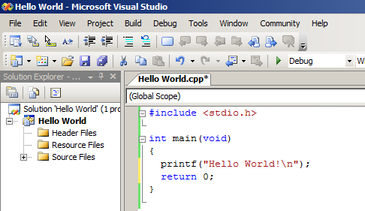

11. Once you have finished typing in the code, press Ctrl + F5, or select Start Without Debugging under the Debug menu. The results of compiling will be displayed in the bottom window, labeled Output. If there is a compilation error, you will see it here. Make sure your code matches the listing exactly. It is very easy to forget a semicolon or to make a typo.

12. You should see a new window appear as shown below:

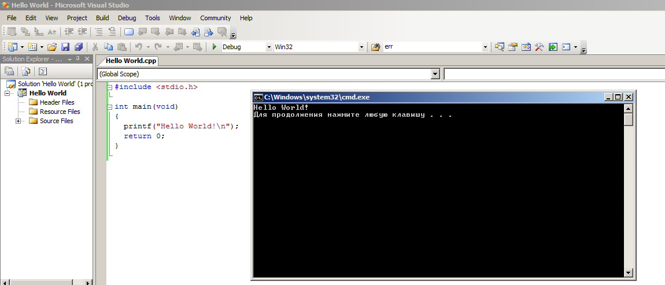

Congratulations, you have just created your first program!

