LOOPS

1. While statements

The while statement is the simplest of the four loops that C++ provides, and it has a definition very similar to that of an if statement:

while (expression)
statement;

A while statement is declared using the while keyword. When a while statement is executed, the expression is evaluated. If the expression evaluates to true (non-zero), the statement executes.

However, unlike an if statement, once the statement has finished executing, control returns to the top of the while statement and the process is repeated.

Let’s take a look at a simple while loop. The following program prints all the numbers from 0 and 9:

#include <stdio.h>

int main(void)
{
int count = 0;
while (count < 10)
{
printf("%d ",count);
count++;
}
printf("done!\n");
return 0;
}

Let’s take a closer look at what this program is doing. First, count is initialized to 0. 0 < 10 evaluates to true, so the statement block executes. The first statement prints 0, and the second increments count to 1. Control then returns back to the top of the while statement. 1 < 10 evaluates to true, so the code block is executed again. The code block will repeatedly execute until count is 10, at which point 10 < 10 will evaluate to false, and the loop will exit.

It is possible that a while statement executes 0 times. Consider the following program:

#include <stdio.h>

int main(void)
{
int count = 15;
while (count < 10)
{
printf("%d ",count);
count++;
}
printf("done!\n");
return 0;
}

The condition 15 < 10 immediately evaluates to false, so the while statement is skipped. The only thing this program prints is done!.

Infinite loops
On the other hand, if the expression always evaluates to true, the while loop will execute forever. This is called an infinite loop. Here is an example of an infinite loop:

#include <stdio.h>

int main(void)
{
int count = 0;
while (count < 10) // this condition will never be false
{
printf("%d ",count); // this line will repeatedly execute
}
return 0;
}

Because count is never incremented in this program, count < 10 will always be true. Consequently, the loop will never terminate, and the program will print "0 0 0 0 0 ..." forever.

We can declare an intentional infinite loop like this:

#include <stdio.h>

int main(void)
{
while (1)
{
// this loop will execute forever
}
return 0;
}

The only way to exit an infinite loop is through a return statement, a break statement, an exit statement, a goto statement, an exception being thrown, or the user killing the program.

Loop variables
Often, we want a loop to execute a certain number of times. To do this, it is common to use a loop variable, often called a counter. A loop variable is an integer variable that is declared for the sole purpose of counting how many times a loop has executed. In the examples above, the variable count is a loop variable. Loop variables are often given simple names, such as i, j, or k.

Each time a loop executes, it is called an iteration.

Consider the program that for a given n finds the sum:
S = $\frac{1}{1⋅2}$ + $\frac{1}{2⋅3}$ + … + $\frac{1}{n⋅(n+1)}$

#include <stdio.h>

int i, n;
double s;

int main(void)
{
scanf("%d",&n);
s = 0; i = 1;
while(i <= n) // loop executes (iterates) n times
{
s += 1.0 / i / (i+1);
i++;
}
printf("%lf\n",s);
return 0;
}

Nested loops
It is also possible to nest loops inside of other loops. In the following example, the inner loop and outer loops each have their own counters. However, note that the loop expression for the inner loop makes use of the outer loop's counter as well!

#include <stdio.h>

int main(void)
{
int outer = 1;
while (outer <= 5)
{
// loop between 1 and inner
int inner = 1;
while (inner <= outer)
printf("%d ",inner++);

// print a newline at the end of each row
printf("\n");
outer++;
}
return 0;
}

2. For statements

By far, the most utilized looping statement in C++ is the for statement. The for statement (also called a for loop) is ideal when we know exactly how many times we need to iterate, because it lets us easily define, initialize, and change the value of loop variables after each iteration.

The for statement looks pretty simple in abstract:

for (init-statement; condition-expression; end-expression)
statement;

The easiest way to understand a for loop is to convert it into an equivalent while loop:

{ // note the block here
init-statement;
while (condition-expression)
{
statement;
end-expression;
}
} // variables defined inside the loop go out of scope here

The variables defined inside a for loop have a special kind of scope called loop scope. Variables with loop scope exist only within the loop, and are not accessible outside of it.

Evaluation of for statements
A for statement is evaluated in 3 parts:
1) The init-statement is evaluated. Typically, the init-statement consists of variable definitions and initialization. This statement is only evaluated once, when the loop is first executed.
2) The condition-expression is evaluated. If this evaluates to false, the loop terminates immediately. If this evaluates to true, the statement is executed.
3) After the statement is executed, the end-expression is evaluated. Typically, this expression is used to increment or decrement the variables declared in the init-statement. After the end-expression has been evaluated, the loop returns to step 2.

Let’s take a look at a sample for loop and discuss how it works:

#include <stdio.h>

int main(void)
{
for (int count = 0; count < 10; count++)
printf("%d ",count);
return 0;
}

First, we declare a loop variable named count, and assign it the value 0.
Second, count < 10 is evaluated, and since count is 0, 0 < 10 evaluates to true. Consequently, the statement executes, which prints 0.
Third, count++ is evaluated, which increments count to 1. Then the loop goes back to the second step. Now, 1 < 10 is evaluated to true, so the loop iterates again. The statement prints 1, and count is incremented to 2. 2 < 10 evaluates to true, the statement prints 2, and count is incremented to 3. And so on.
Eventually, count is incremented to 10, 10 < 10 evaluates to false, and the loop exits.

Find the sum of numbers from 1 to n:

#include <stdio.h>

int main(void)
{
int s, i, n;
scanf("%d",&n);
for (s = 0, i = 1; i <= n; i++)
s = s + i;
printf("%d\n",s);
return 0;
}

Omitted expressions
It is possible to write for loops that omit any or all of the expressions. For example:

#include <stdio.h>

int main(void)
{
int count = 0;
for ( ; count < 10; )
printf("%d ",count++);
printf("\n");
return 0;
}

Rather than having the for loop do the initialization and incrementing, we've done it manually. We have done so purely for academic purposes in this example, but there are cases where not declaring a loop variable (because you already have one) or not incrementing it (because you're incrementing it some other way) are desired.

Although you do not see it very often, it is worth noting that the following example produces an infinite loop:

for (;;)
statement;

The above example is equivalent to:

while (true)
statement;

Multiple declarations
Although for loops typically iterate over only one variable, sometimes for loops need to work with multiple variables. When this happens, the programmer can make use of the comma operator in order to assign (in the init-statement) or change (in the end-statement) the value of multiple variables:

#include <stdio.h>

int main(void)
{
int i, j;
for (i = 0, j = 9; i < 10; i++, j--)
printf("%d %d\n",i,j);
return 0;
}

This loop assigns values to two previously declared variables: i to 0, and j to 9. It iterates i over the range 0 to 9, and each iteration i is incremented and j is decremented.

3. Break and Continue

Break
It is sometimes desirable to skip some statements inside the loop or terminate the loop immediately without checking the test expression. The break statement terminates the loop (for, while) immediately when it is encountered. The break statement is used with decision making statement such as if…else.
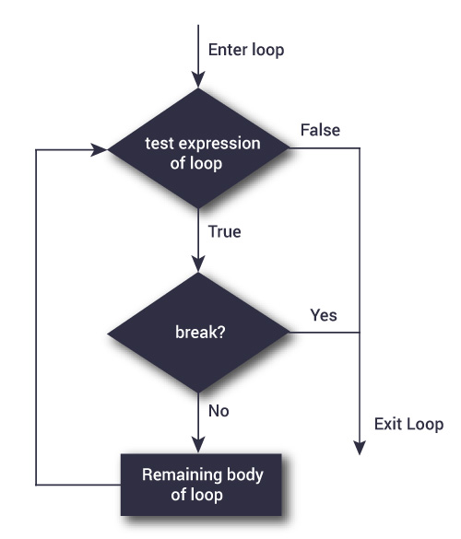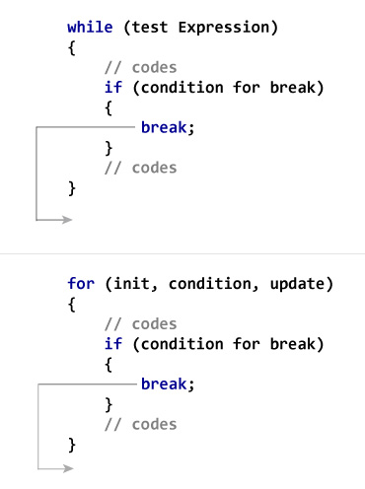
Next program calculates the sum of integers until user enters nonnegative number.

#include <stdio.h>

int s, x;

int main(void)
{
s = 0;
while(true)
{
scanf("%d",&x);
// if user enters negative number, loop is terminated
if (x < 0) break;
s = s + x;
}
printf("%d\n",s);
return 0;
}

Continue
The continue statement skips some statements inside the loop. The continue statement is used with decision making statement such as if…else.

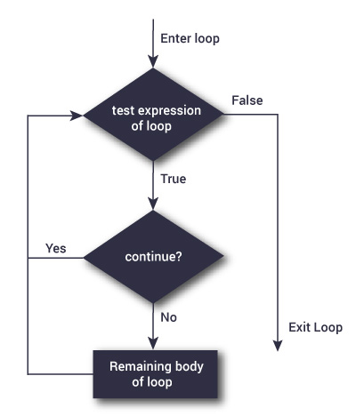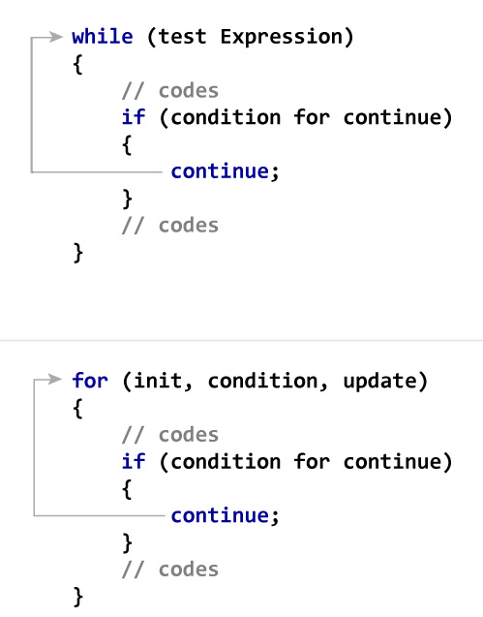
Next program calculates the sum of maximum of 5 numbers. Negative numbers are skipped from calculation.

#include <stdio.h>

int i, s, x;

int main(void)
{
s = 0;
for(i = 0; i < 5; i++)
{
scanf("%d",&x);
// if user enters negative number, loop is continued
if (x < 0) continue;
s = s + x;
}
printf("%d\n",s);
return 0;
}

